## Creating a virtual network in the Azure portal

Azure Virtual Network represents your local network in the cloud. It enables other Azure resources to communicate over a secure private network without exposing endpoints over the internet.

### Getting ready

Before you start, open a web browser and go to the Azure portal at

https://portal.azure.com.

### How to do it...

In order to create a new virtual network using the Azure portal, use the following steps:

1. In the Azure portal, select **Create a resource** and choose **Virtual network**

under **Networking** services (or, search for virtual network in the search bar).

1. A new blade will open where we need to provide information for the virtual network, including a **Name**; define the **Address space**; select the **Subscription** option we want to use; select the **Resource group** option for where the virtual network will be deployed; select a **Location** (of the Azure datacentre) for where the virtual network will be deployed; and define the **Name** and **Address range** for the first subnet. We also have the option to select what kind of **DDoS protection** we want to use and if we want to use the **Firewall** option. An example is shown in the following screenshot:

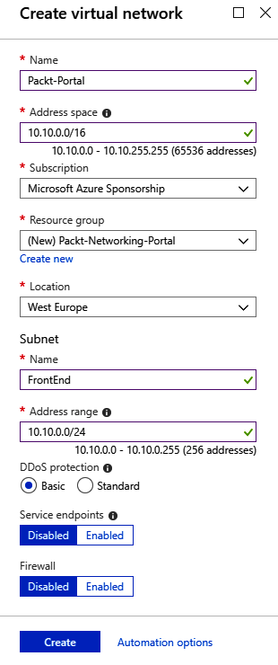

1. Creating a virtual network usually doesn’t take much time and should be completed in under two minutes. Once deployment is finished, you can start using the virtual network.

### How it works...

We deploy virtual networks to **Resource group** under **Subscription** in the Azure datacentre that we choose. **Location** and **Subscription** are important parameters; we will only be able to attach Azure resources to this virtual network if they are in

the same subscription and region as the Azure datacentre. The **Address space** option

defines the number of IP addresses that will be available for our network. It uses the **Classless Inter-Domain Routing** (**CIDR**) format, and the largest range we can choose is /8. In the portal, we need to create an initial subnet and define the subnet address range. The smallest subnet allowed is /29 and the largest is /8 (however, this can’t be larger than the virtual network range).

## Adding a subnet in the Azure portal

Beside adding subnets while creating a virtual network, we can add additional subnets to our network at any time.

### Getting ready

Before you start, open a web browser and go to the Azure portal at

https://portal.azure.com. Here, locate the previously created virtual network.

### How to do it...

In order to add a subnet to a virtual network using the Azure portal, we must follow these steps:

1. In the virtual network blade, go to the **Subnets** section.
2. Select the **Add subnet** option.
3. A new blade will open. We need to provide information for the subnet, including the **Name** and **Address range** in CIDR format. The **Address range** must be in the range limit of the virtual network’s address range and cannot overlap with the address range of other subnets in the virtual network. Optionally, we can add information for **Network security group**, **Route tables**, **Service endpoints** and **Subnet delegation**. These options will be covered in later recipes:

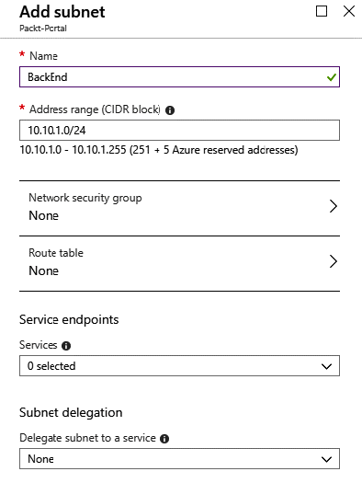

1. We can also add a gateway subnet in the same blade. To add a gateway subnet, select the **Gateway subnet** option.

For a gateway subnet, the only parameter we need to define is the **Address range**. The same rules apply as for adding a regular subnet. This time, we don’t have to provide a name, as it’s already defined. You can add only one gateway subnet per virtual network. Service endpoints are not allowed in the gateway subnet:

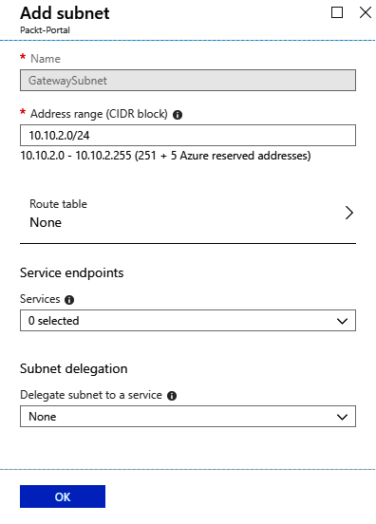

1. After the subnets are added, we can see the newly created subnets in the

**Subnets** blade under the virtual network:

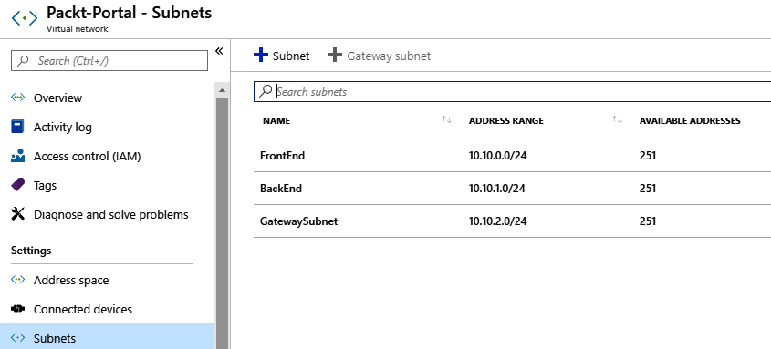

### How it works...

A single virtual network can have a multiple number of subnets defined. Subnets can’t overlap and must be within the virtual network’s address range. For each subnet, four IP addresses are used for management and can’t be used. Depending on the network settings, we can define the communication rules between subnets in the virtual network. A gateway subnet is used for **Virtual Private Network** (**VPN**) connections, and this will be covered in later chapters.

## Changing the address space size

After the initial address space is defined during the creation of a virtual network, we can still change the address space size as needed. We can either increase or decrease the size of the address space, or change the address space completely by using a new address range.

### Getting ready

Before you start, open a web browser and go to the Azure portal at

https://portal.azure.com.

### How to do it...

In order to change the address space size for a virtual network using the Azure portal, we must follow these steps:

1. In the virtual network blade, locate **Address space** under **Settings**.
2. Click on **Address space** and change the value. An example is shown in the following screenshot:

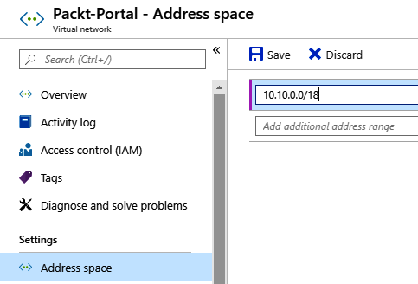

1. After you have entered a new value for **Address space**, click **Save** to apply the changes.

### How it works...

Although you can change the address space at any time, there are some rules that determine what you can or cannot do. Address spaces can’t be decreased if you have subnets defined in the address space that wouldn’t be covered by the new address space. For example, if the address space was in the range of 10.0.0.0/16, it would cover addresses from 10.0.0.1 to 10.0.255.254. If one of the subnets was defined as 10.0.255.0/24, we wouldn’t be able to change the virtual network to 10.0.0.0/17, as this will leave the subnet outside the new space.

The address space can’t be changed to a new address space if you have subnets defined. In order to completely change the address space, you need to remove all subnets first. For example, if we have the address space defined as 10.0.0.0/16, we wouldn’t be able to change it to 10.1.0.0/16, since having any subnets in the old space would leave them in an undefined address range.

## Changing a subnet’s size

Similar to the virtual network address space, we can change the size of a subnet at any time.

### Getting ready

Before you start, open a web browser and go to the Azure portal, at

https://portal.azure.com.

### How to do it...

In order to change subnet size using the Azure portal, follow these steps:

1. In the virtual network blade, select the **Subnets** option.
2. Select the subnet you want to change.
3. In the **Subnets** option, enter a new value for the subnet size under **Address range**. An example of how to do this is shown in the following screenshot:

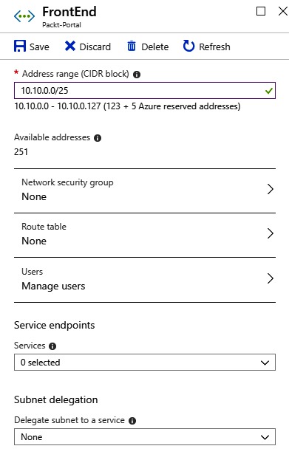

1. After entering a new value, click on **Save**.
2. In the **Subnets** list, you can see that the changes have been applied and the address space has changed, as shown in the following screenshot:

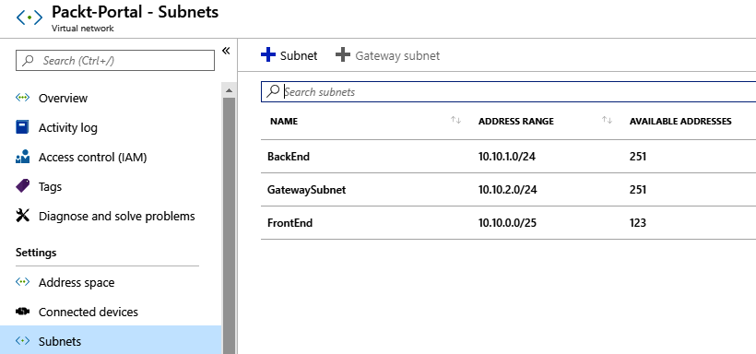

### How it works...

When changing subnet size, there are some rules that must be followed. You can’t change the address space if it’s not within the virtual network’s address space range, and the subnet range can’t overlap with other subnets in a virtual network. If devices are assigned to this subnet, you can’t change the subnet to exclude the addresses that these devices are already assigned to.